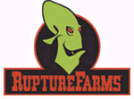
Rupture Farms
90 Farms Road
Sligs Town, Oddworld
5 Star Service!
Call service free!
“Best meat!” Guiness Records
Buy in Rupture Farms
Call for a order (first order free!)

