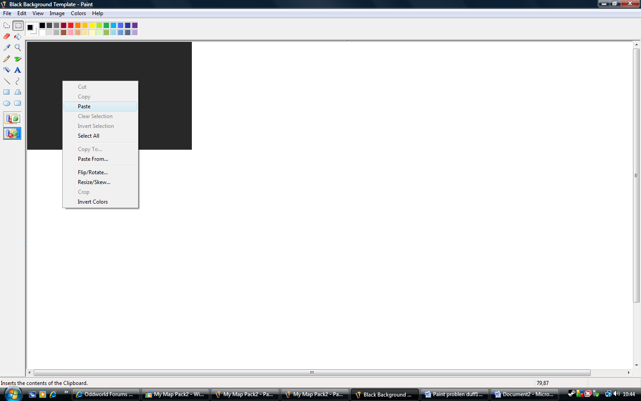
Paste it into the other MS paint. (Which I also saved as a 24 bit BMP file) See next document #6

