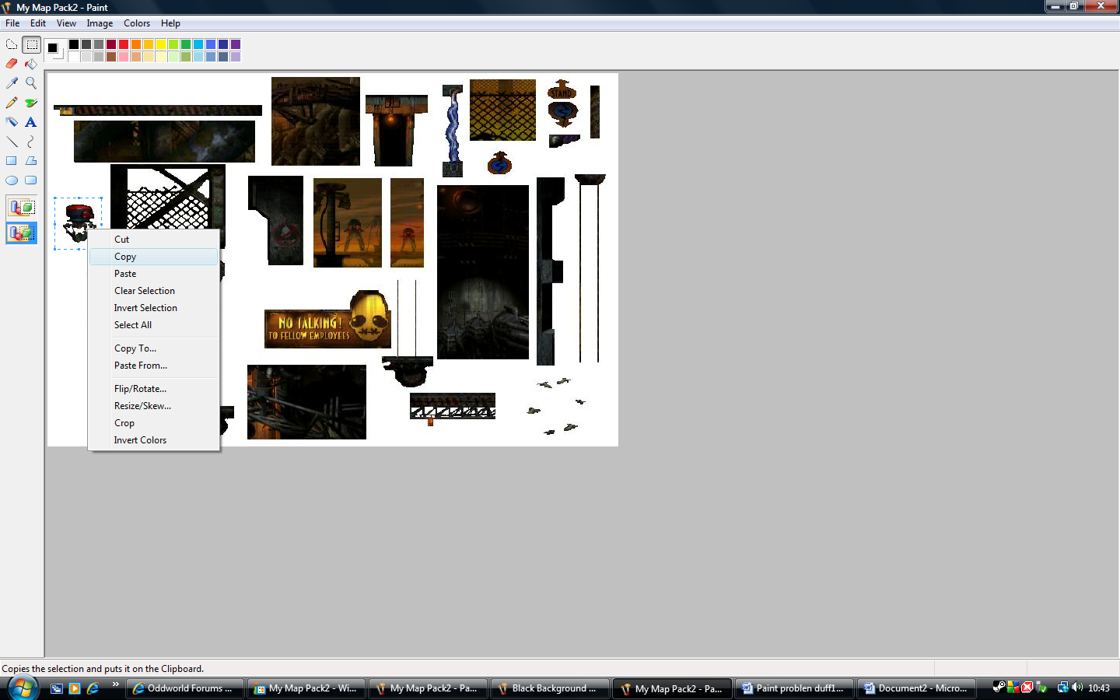
I copy my object. See next document (#5)

