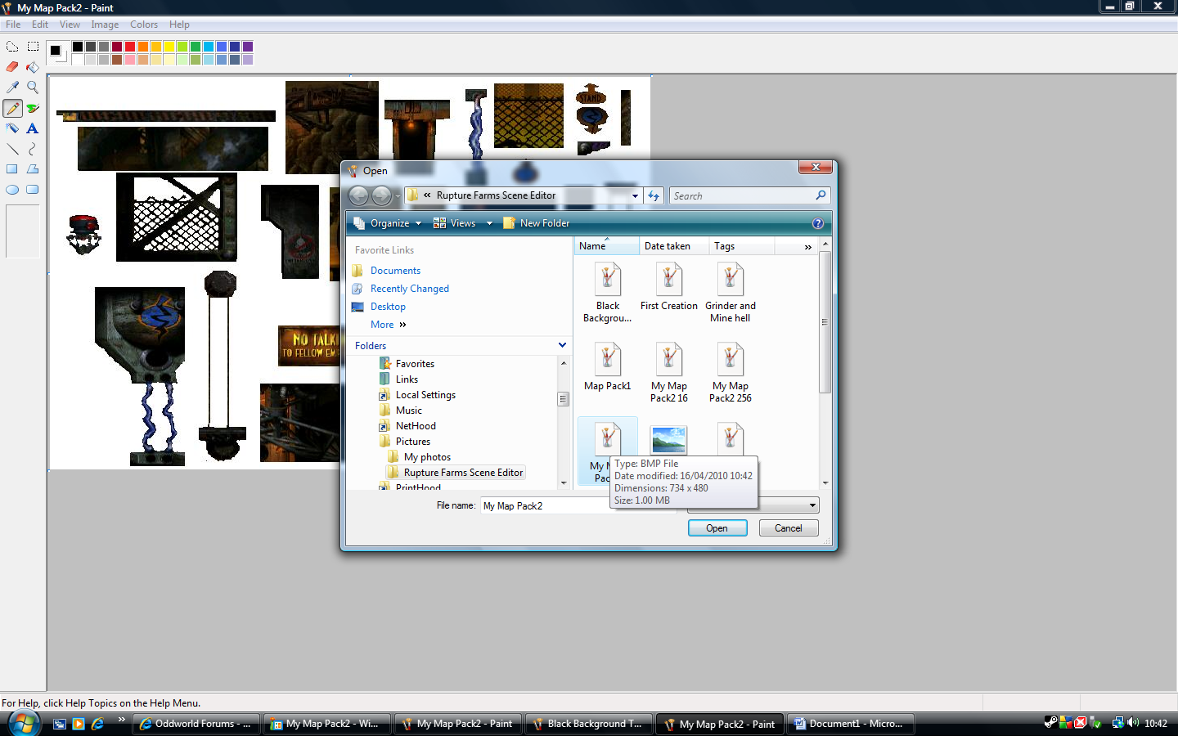
I open my new BMP file. (See next document) #4

