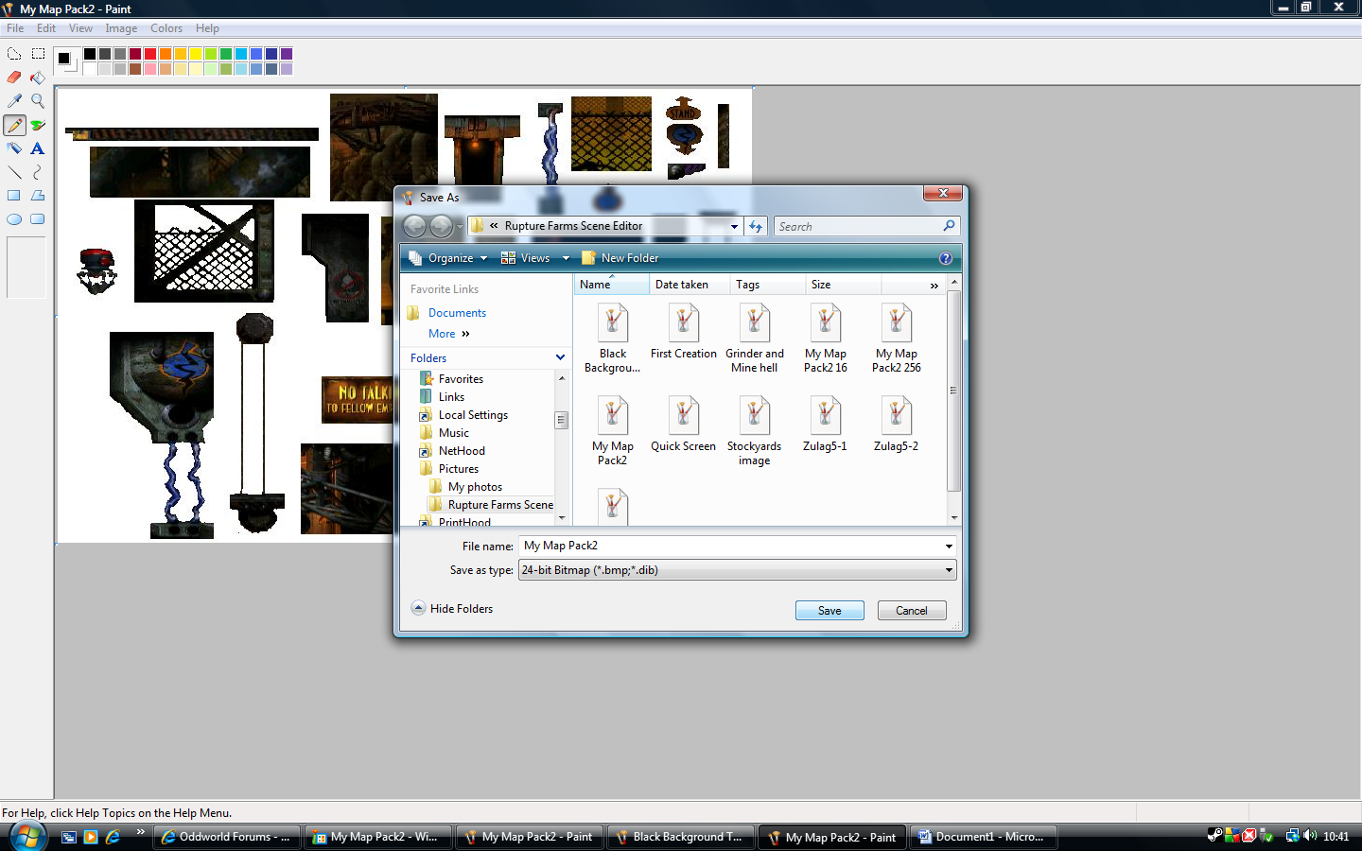
I then save it as a 24 bit bitmap (.bmp) See next document (#3)

