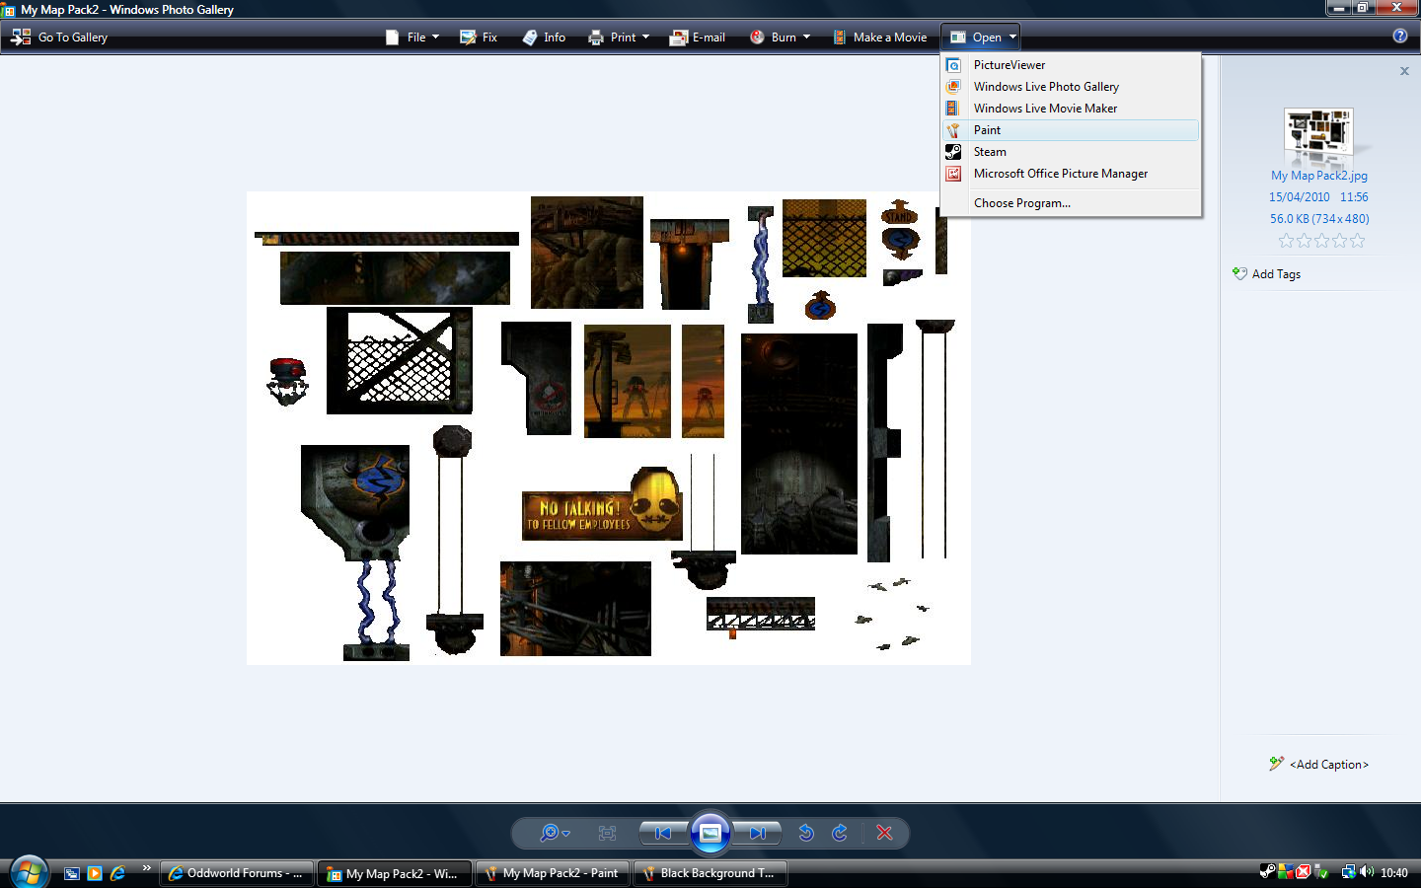
I get the jpeg file and open it in paint. See next document (#2)

